Student Numbers: Emails: FIRST NAMES Family / last NAMES
RASHIK
MAHARJAN
6
4
0
5 0
3
2
2
Maharjan.Maharjan@uon.edu.au
MADHAV
2
6
8
2
0
5
3
Madhav.sharma@uon.edu.au
SHARMA

SHAMA
PRAVEEN
2
6
0
7
4 43
3
3 3
C3470623@uon.edu.au
URVASHI
RANI
0
6
6
6
9
4
3
URVASHI.RANI@uon.edu.au

Anu.Shrestha@uon.edu.au
2
4
3
0
5
350
ANU
SHRESTHA
6
Course Code Course Title
BUISNESS INTELLIGENCE FOR THE ENTERPRISE
9
0
0
6
0
F
N
I
(Example) (Example)
Intro to University
1
D
C
B
A
4
3
2
Campus of Study: Sydney,Callaghan (eg Callaghan, Ourimbah, Port Macquarie)

Assessment Item Title: ASSESSMENT 2 Due Date/Time:

Tutorial Group (If applicable): Word Count (If applicable):

Lecturer/Tutor Name: MARCELLA PAPINI

Extension Granted: Yes No Granted Until:

Please attach a copy of your extension approval
NB: STUDENTS MAY EXPECT THAT THIS ASSIGNMENT WILL BE RETURNED WITHIN 3 WEEKS OF THE DUE DATE OF SUBMISSION
Please tick box if applicable
Students within the Faculty of Business and Law, Faculty of Science, Faculty of Engineering and Built Environment and the School of Nursing and Midwifery: We verify that we have completed the online Academic Integrity Module and adhered to its principles.
Students within the School of Education: We understand that a minimum standard of correct referencing and academic literacy is required to pass all written assignments in the School of Education; and we have read and understood the School of Education Course Outline Policy Supplement, which includes important information related to assessment policies and procedures.

- .

We declare that this assessment item is our own work unless otherwise acknowledged and is in accordance with the University’s Student Academic Integrity Policy 13/10/2024

DATE
STAMP
HERE

10/13/2024
We certify that this assessment item has not been submitted previously for academic credit in this or any other course. We certify that we have not given a copy or have shown a copy of this assessment item to another student enrolled in the course, other than members of this group.
We acknowledge that the assessor of this assignment may, for the purpose of assessing this assignment:
- Reproduce this assessment item and provide a copy to another member of the Faculty; and/or
- Communicate a copy of this assessment item to a plagiarism checking service (which may then retain a copy of the item on its database for the purpose of future plagiarism checking).
- Submit the assessment item to other forms of plagiarism checking.

We certify that any electronic version of this assessment item that we have submitted or will submit is identical to this paper version.

Turnitin ID:
(if applicable)

Signature: _____Rashik Maharjan______________________________ Date: ____10/12/2024_______

Signature: _____Madhav Sharma___________________________________ Date: 10/12/24

Signature: ______Shama Praveen___________________________ Date: 10/12/2024___________

Signature: _______Urvashi Rani______ __________________________ Date: _10/12/2024__________

Signature: ________Anu Shrestha_________________________________ Date:_10/12/2024______

TABLE OF CONTENT:

Data Understanding and Preparation (Exploratory Data Analysis - EDA) 2
Dataset Loading (Extraction) 3
Structure of the Data (Transforming) 4
Missing Data 5
Duplicate Value 5
Identify Outliers in Numerical Columns Using Box Plots 6
Use the Z-Score Method to Detect Outliers: 7
Detect Outliers in Categorical Columns: 8
LOAD 9
Data Modelling (Designing a Star Schema) 10
STAR SCHEMA 12
Analysis Report: Best Field Officer Performance Dashboard 14
Introduction: 14
Key Performance Indicators (KPIs): 14
Dashboard Charts Overview: 14
Analysis: 19
Conclusion: 20

Data Understanding and Preparation (Exploratory Data Analysis - EDA)

Exploratory Data Analysis aims to reveal such quantitative characteristics of the data and their dependencies as are worth focusing on. It is necessary when you need to look at some data patterns, see outliers, check hypothesis and verify the data distribution before feeding it into other complex processing methods or even any complex model.

The data cleaning step also occurs in this sequence and pre-processing aims at making the gathered data fit or usable depending on the subsequent analysing stage. If we follow through with all the steps involved within EDA, then at the end of the process we should be in possession of a good understanding of data and a cleaned up structured form of the data for analysis.

Dataset Loading (Extraction)

The dataset is imported into Python using the Pandas library to perform analysis that is specific to data science. First, pandas are designed for working with structured data in specific file formats – CSV, Excel, and databases, so it is perfect for this Task. When the dataset has been uploaded to the environment, it is possible to perform cleaning and transformation, or data analysis and modeling.

In this project the data was given in excel form. The following Python code snippet demonstrates how the dataset was imported into the environment using the pd.read_excel() function from Pandas:

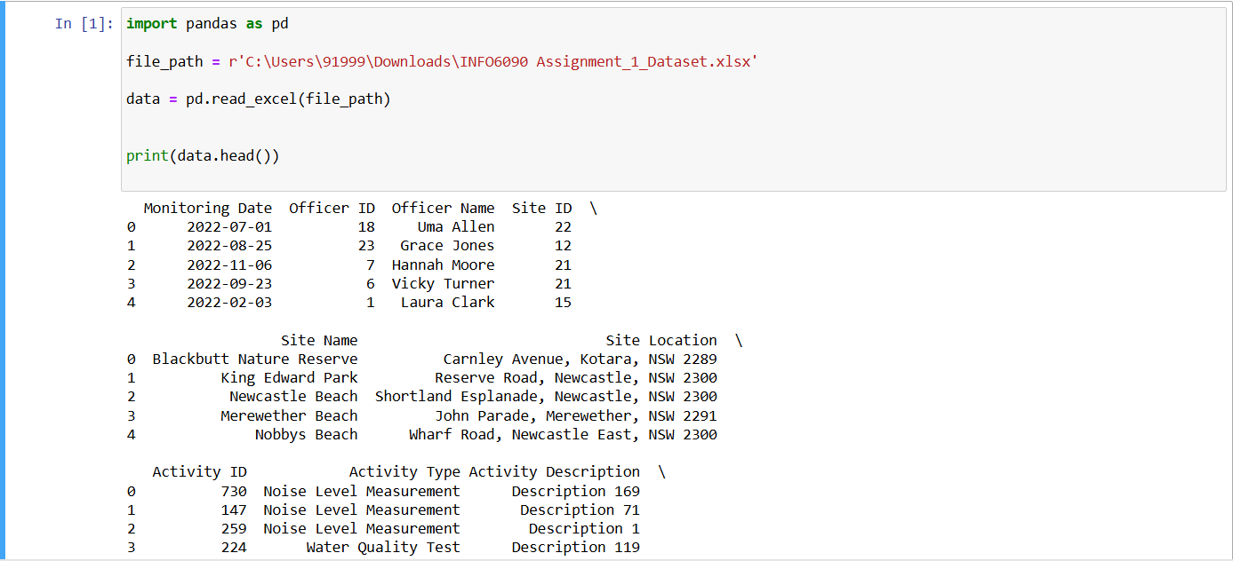
Once the data set was successfully loaded into the environment, we went on with the first exploratory data analysis for basic data profiling activities to check the level of cleanliness and preparation of the data for the next processes. The columns and the data types were checked by reviewing the first several rows of the corresponding dataset. This step is an initial phase of the EDA and the subsequent operating steps, including missing value detection or outlier identification or preprocessing for more complex operations.

Structure of the Data (Transforming)

This dataset for this analysis consists of several variables of interest that provide the performance measures of field officers. Every variable (or column) in this table corresponds to a particular aspect of the officer’s work; the unique identification number, performance rating, compliance indicator, and the number of hours spent monitoring among them. To achieve this, it is important for any individual who plans to analyze this data to first understand the structure of this dataset.

The table below summarizes the dataset’s structure, including the column names and their corresponding data types:

Column Name | Data Type
Monitoring Date | datetime64[ns]
Officer ID | int64
Officer Name | object
Site ID | int64
Site Name | object
Site Location | object
Site Location | object
Activity ID | int64
Activity Type | object
Activity Description | object
Activity Duration (hours) | float64
Equipment Used | object
Pollution Level Detected | float64
Compliance Status | object
Community Feedback Rating | int64
Transaction ID | int64

Missing Data

After analyzing the given set no missing values in any of the columns were identified. All the columns have full datasets with no missing values so there are no more additional processes including imputation or exclusion of rows as well. This is an advantage because it leads to easier analysis without the need for assumption or altering the data.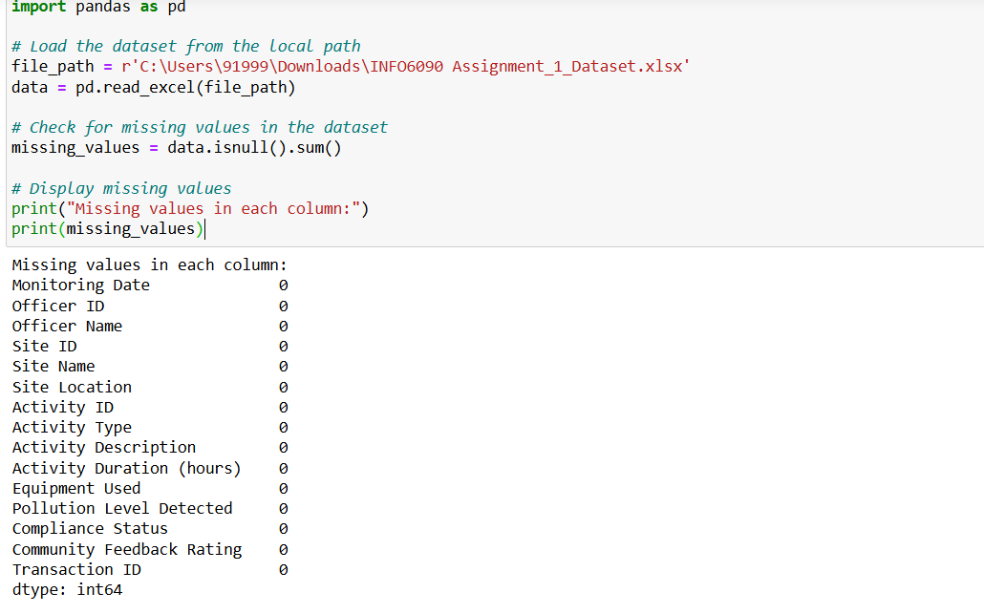

Duplicate Value

There is no Duplicate Value Available in the dataset.

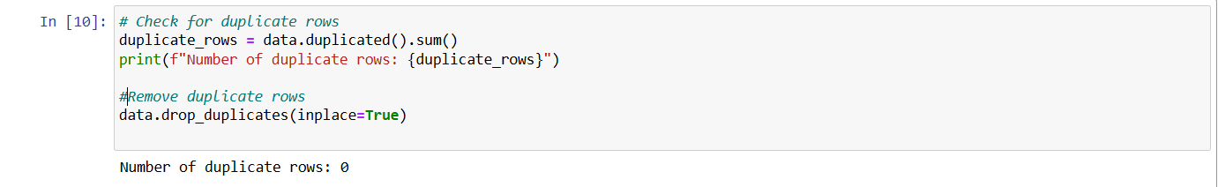

Identify Outliers in Numerical Columns Using Box Plots

From this plot, one gets the impression that there’s no Outlier or Abnormality in the Activity Duration (hours), Pollution Level, Community Feedback column. There are no abnormal values concerning the values mentioned in this study.

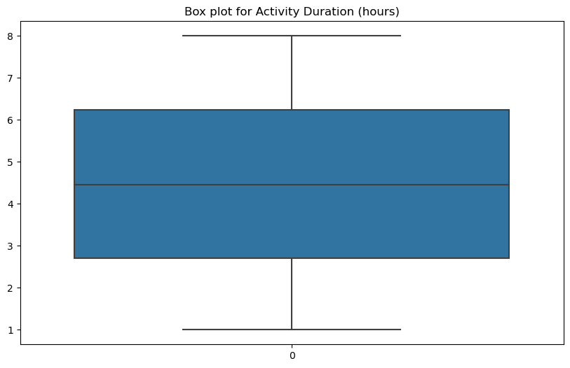

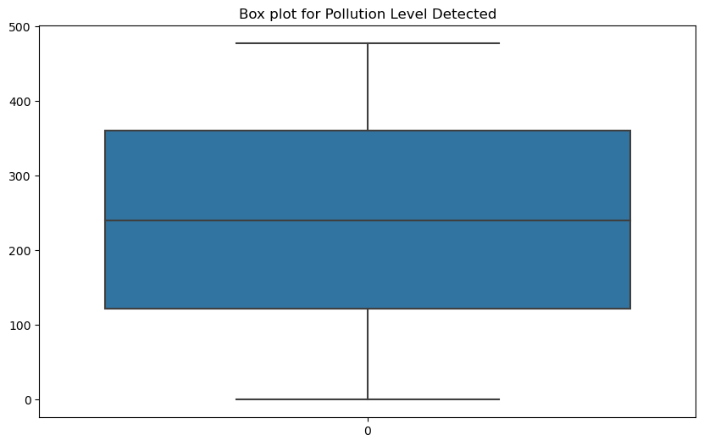
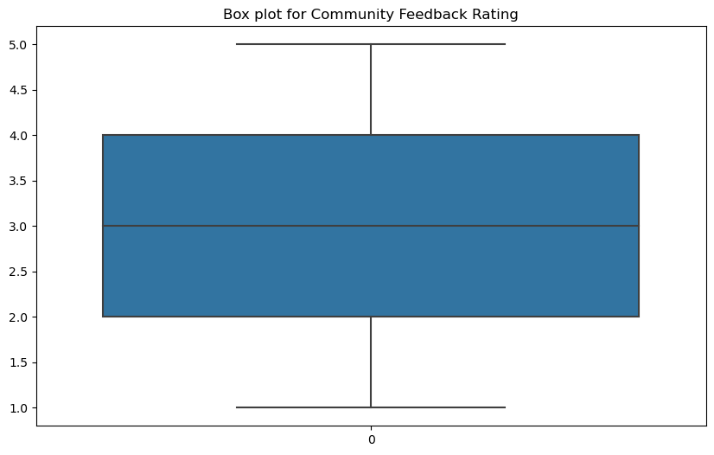

Use the Z-Score Method to Detect Outliers:

According to Z score method,
Looking at our numerical data, it does not appear out of the ordinary using the Z-score method and there are no extreme values that one can point at.
Which is preferable since, if the outliers are deleted, this means that the data is not very noisy and does not contain extreme outliers that could distort the results of the analysis.

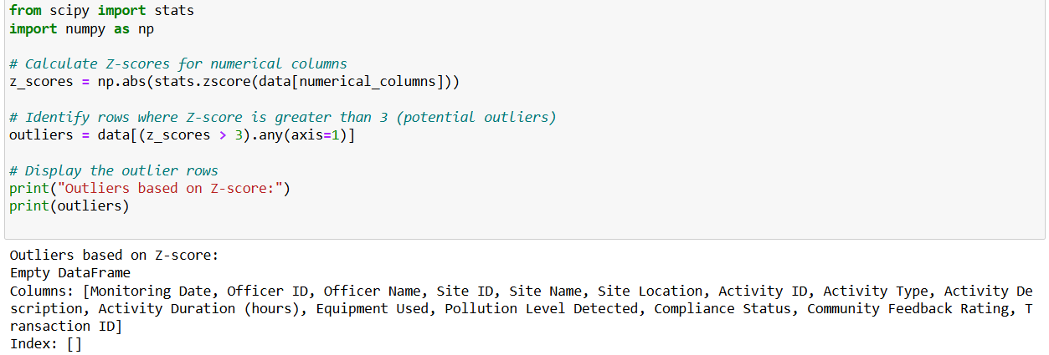

Detect Outliers in Categorical Columns:

Based on the frequency distributions of the categorical variables:
Compliance Status, Activity Type, and Equipment Used do not show any major deviations.
The distribution of the data for the three categories in the figure above appears to be reasonably good.

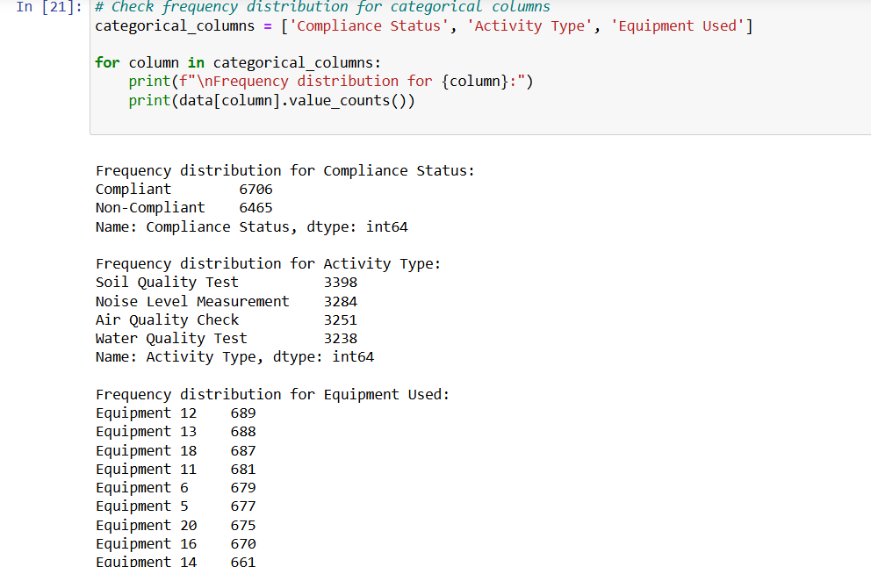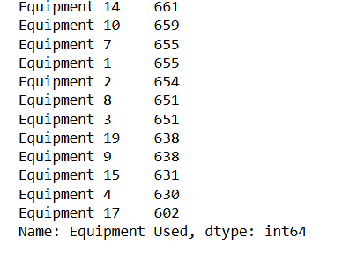

LOAD

The final process is loading cleaned and transformed data into a suitable format for analysis, and subsequent reporting or transfer to other systems.
The cleaned dataset was stored using pandas as either an Excel file to facilitate ease of use when output to other applications for analysis or reporting. This helps in that it makes sure that the data it is storing is in a format that is optimized to be utilized in as many tools as possible, across different environments.

The file can be imported to analytical applications or database based on the project's need.
The following process was followed to load the cleaned dataset:
File Format: The format for the dataset was an Excel file because the format is easily exported to most analytical and reporting tools.
File Path: Then the cleaned data was saved at a particular path for the file to enhance easy access to the data for further analysis.
File Structure: This file had retained the names of the columns as well as the format like the input file, while erasing all invalid data, outliers or missing values with which were dealt in the transformation stage.

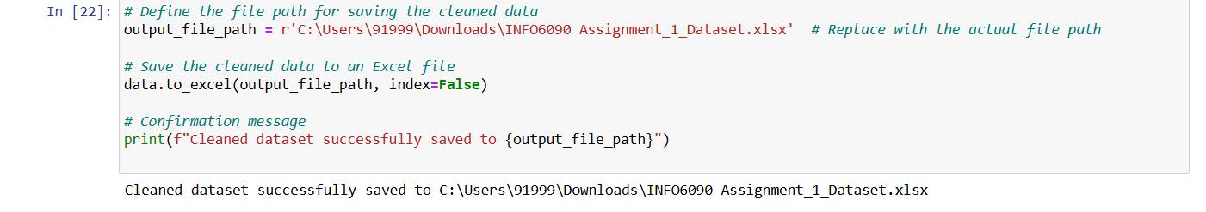

Data Modelling (Designing a Star Schema)

Before modeling data, we analyzed the source data carefully where we found some data inconsistencies with officer and site details which we have cleaned with few assumptions.
Assumptions:
- The file contains 25 unique officer ids (1 to 25). We have assigned this unique id to unique officer name on alphabetical order. This is the case for officer details. As shown in the screenshot below, the officer id for ‘Uma Allen’ is multiple in the source data but after the assumption and cleaning the data, there is only one officer id for ‘Uma Allen’.
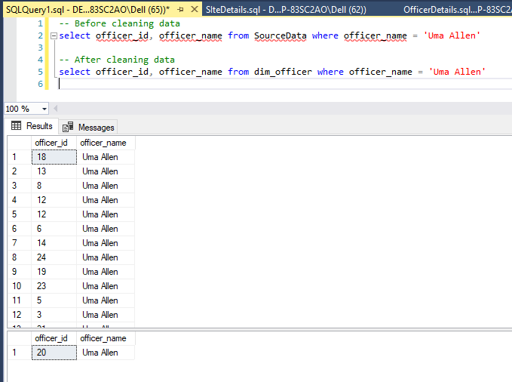
- The file contains 24 distinct site ids and 23 distinct site names. We have assigned 23 unique site id to 23 unique site names randomly but for one site id the site name will be null. This is the case for site details. As shown in the screenshot below, the site id for ‘Lambton Park’ is multiple in the source data but after assumption and cleaning data, there is only one site id for ‘Lambton Park’.
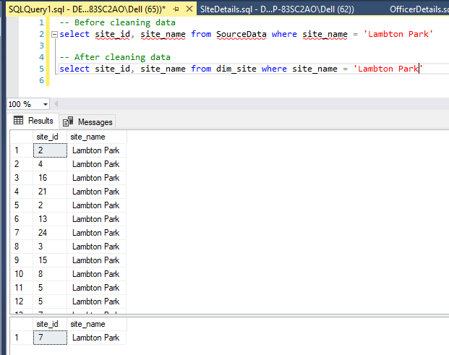
These assumptions are considered without hampering other columns in the source data.

STAR SCHEMA
We break down the data into multiple parts to design the multi-dimensional data model (star schema) to build a database. Below is our star schema.
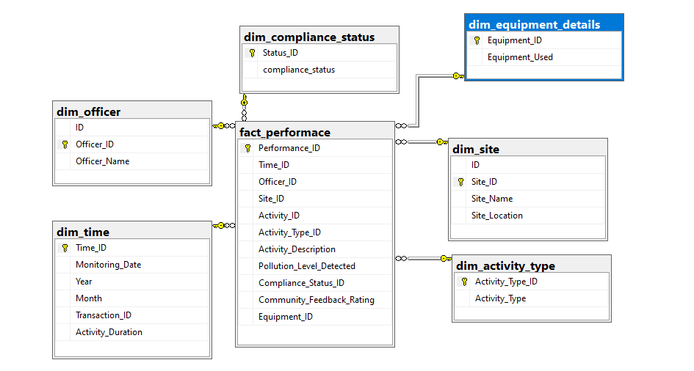
Fact Table | Dimensional Table
fact_performace | dim_activity_type
 | dim_compliance_status
 | dim_equipment_details
 | dim_officer
 | dim_site
 | dim_time

Justification in design decisions
A star schema is a simple and effective structure to design database model which consists of a fact table and several dimensional tables. One important factor between fact and dimensional table is that they must have at least one common (primary key) column to map between two tables. Fact table holds important data which is measurable. Similarly, dimension tables add context to the data. For instance, dim_officer contains officer name with unique id and fact table can use unique id which is more effective in two ways.
- Unique id is int and integer holds less space than the varchar.
- Easy to maintain using indexing and retrieve using joins.
Some limitations of the model:
With the increase in data volume could be a challenge. If the fact table grows, then the query performance will be slow and may need additional strategy to tune performance. Change in the business rules can impact on the whole process of working.

Analysis Report: Best Field Officer Performance Dashboard

Introduction:
The insights in this report are based on the Performance Dashboard for the Best Field Officer in Power BI, which was developed for the Environment Protection Agency in Newcastle. This dashboard is a valuable resource for analyzing and visualizing data, with a specific focus on important performance indicators related to the activities of field officers and their engagement with the community.

Key Performance Indicators (KPIs):
At the top of the dashboard, we highlight the following KPIs:
- Total Number of Officers: 25
- Average Activity Duration: 4.47 hours
- Average Pollution Level: 253.36 ppm
- Average Performance Score: 0.76
- Total Activities: 4
These KPIs provide a comprehensive overview of the field officers' performance and efficiency in their activities.

Dashboard Charts Overview:
- Monthly activity count by compliance Status
- Chart Type: Line Chart
- Description: I started by examining the monthly activity count, with a specific focus on compliance status, which is essential for evaluating performance. This graph illustrates the monthly activity count grouped by compliance status (compliant versus non-compliant). The consistent rise in compliant activities demonstrates the commitment of the officers to following rules and regulations, bolstering overall environmental protection efforts. In contrast, the notable decrease in non-compliant activities indicates that effective monitoring and compliance strategies are effectively in place, further reinforcing the positive trend in operational adherence.
- Visualization:

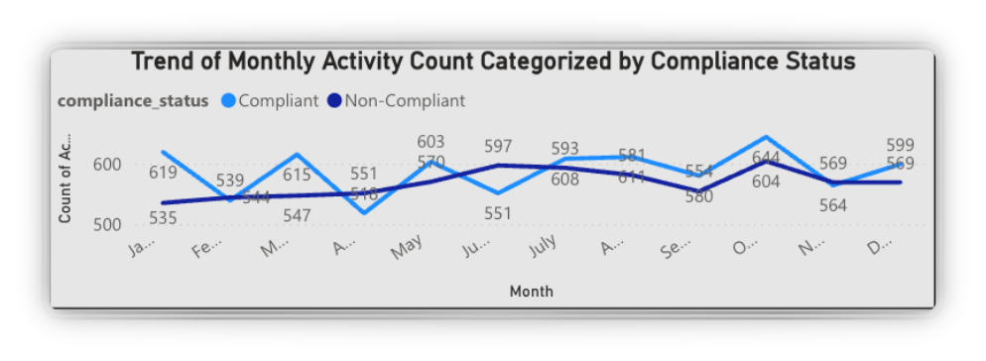

- Average Performance score per officer
- Chart Type: Line chart
- Description: The distribution of performance scores among the officers is depicted in this box plot. Jane's performance score of 0.85 is emphasised, indicating that she is a top performer above the median score. The range of scores can be useful in detecting outliers and pinpointing areas for performance enhancement within the team.
To find the Performance Score, I combined several key factors that reflect both the quantity and quality of each officer's work. Here's how I calculated it:
- First, I filtered the data to include only officers who followed the rules (Compliance Status). Then, I calculated:
- Total activities per officer
- Average pollution detection level
- Average activity duration
- Average community feedback
- Average Total Cost
After normalizing the data, I calculated the Performance Score using this formula:

Performance Score = (0.4 * Normalized Activities + 0.3Normalized_Compliance + 0.2 * (1 - Normalized Duration) + 0.1 * Normalized Pollution)
Jane White had the highest score, making her the top
- Visualization:

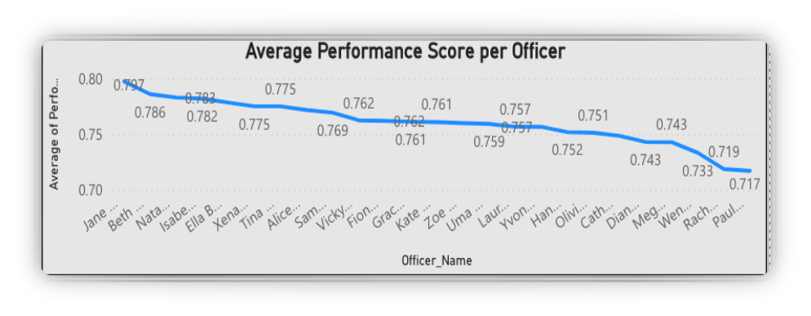

- Total coast
- Chart Type: Line Chart
- Description: The total expenditures of every officer are compared in this chart, demonstrating Jane's cost efficiency with a total spending average of 0.04. The visual representation emphasizes how Jane's costs are less than both the average 0.09 and her peers, showcasing her resource management skills.
- Visualization:

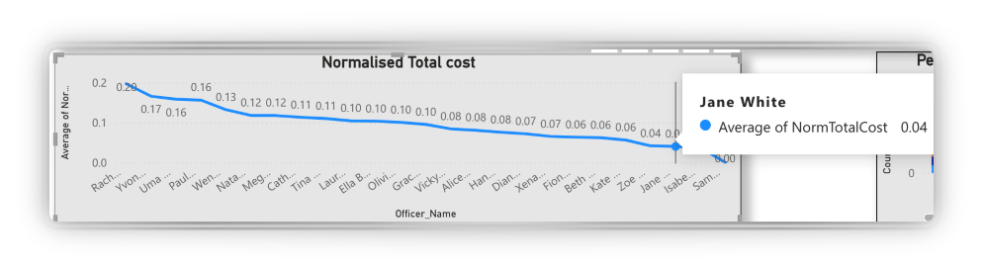
- Community Feedback and Officer Performance
- Chart Type: Bar Chart
- Description: I examined the total community feedback for each officer in the chart, along with a legend indicating customer feedback ratings. Jane White's exceptional performance and high level of engagement in the field are reflected in the fact that she/he received the most positive feedback from the community.
- Visualization:
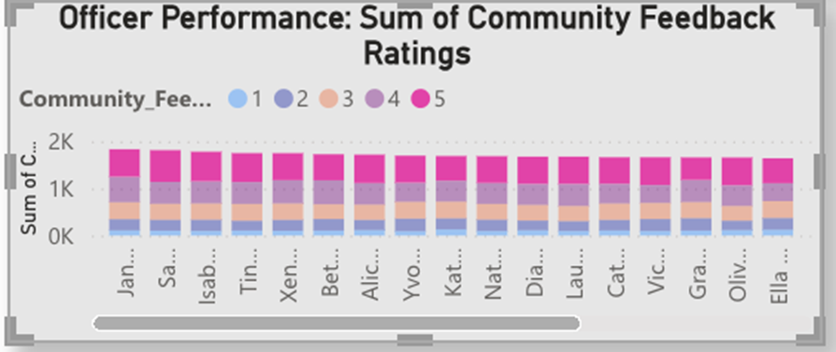

- Activities and feedback ratings
- Chart Type: Bar Chart
- Description: The bar chart displays a comparison of activity counts by officer name along with a legend indicating customer feedback ratings. Once more, Jane White is at the forefront with the most activities and consistently positive feedback ratings.
- Visualization:

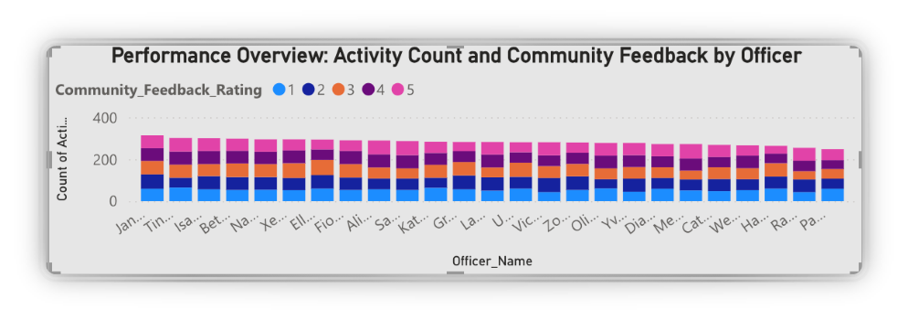

- Pollution detection levels
- Chart Type: Bar Chart
- Description: The average pollution detection levels for each officer have been graphed. Jane White's pollution detection level closely aligns with the overall average, suggesting that she/he does not detect an unusually high amount of pollution but remains attentive to her responsibilities.
- Visualization:

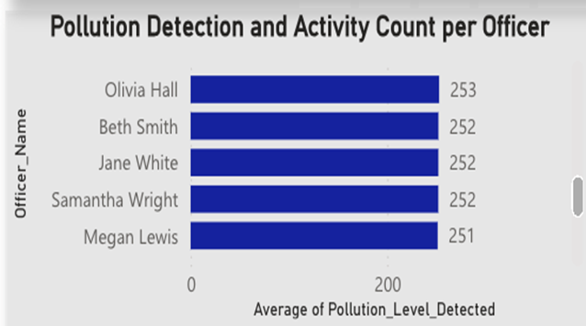
- Activity Duration analysis
- Chart Type: Bar Chart
- Description: The average duration of activity by officer name is depicted in this chart. Jane White's average activity duration aligns with the overall average, indicating a well-balanced approach in terms of quality and efficiency without being overly slow or fast.
- Visualization:

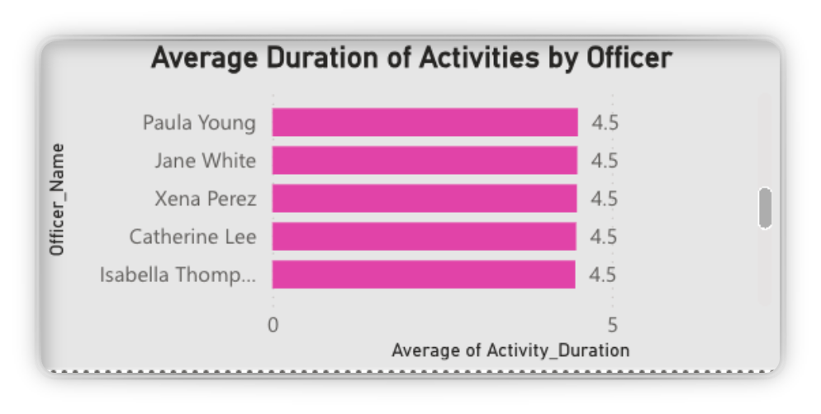

Analysis:

Engagement Metrics:
The dashboard displays a total activity count of 601, indicating the officers' strong dedication to community engagement and compliance monitoring. This high level of engagement is crucial for upholding environmental standards.

Performance Comparison:
The officers' average performance score of 0.76 places them comfortably within the expected performance range. Jane particularly shines with a performance score of 0.85, showcasing exceptional efficiency and effectiveness compared to her colleagues.

Community Interaction:
The average community feedback score of 3.05 suggests generally positive interactions, which are essential for the agency’s mission. Officers with higher feedback ratings are linked to better performance metrics, underscoring the significance of community relationships.

Cost Analysis:
Jane's total expenditure average of 0.04 is notably lower than both the average total cost of 0.09 and her peers. This efficiency underscores her effective resource management, allowing her to provide high-quality services while keeping costs to a minimum.

Conclusion:
The Field Officer Performance Dashboard provides valuable insights into the effectiveness and efficiency of field officers. The data emphasizes Jane's outstanding performance, characterized by her high engagement levels and cost efficiency, which can set a standard for her colleagues. This information can guide future strategies for enhancing performance and optimizing resources within the agency.

